**IBM NALAIYA THIRAN**

**Virtualeye- Lifeguardforswimmingpooltodetectactivedrowning**

3e-HhWSW_400x400**TEAM ID : PNT2022TMID12092**

**Virtualeye- Lifeguardforswimmingpooltodetectactivedrowning**

Safety in swimming pools is a crucial issue. In this, areal-time drowning detection method based on HSVcolor space analysis is presented which uses priorknowledge of the video sequences to set the bestvaluesforthe colorchannel

3e-HhWSW_400x400

3e-HhWSW_400x400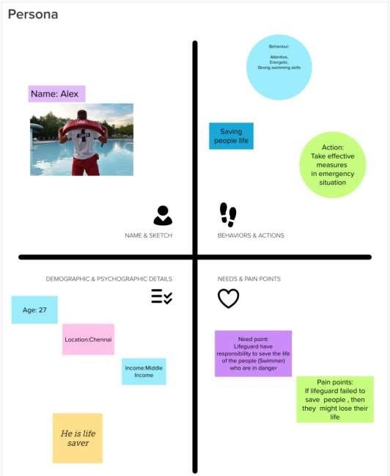Persona&Context(Empathymap)

3e-HhWSW_400x400

**TEAMID : PNT2022TMID12092**

**TEAM MEMBER:**

**1. PRITHIVRAJ T (73151915043) TEAM LEAD**

**2. MOHANASELVAN D V(73151915034)**

**3. SANJAY R(73151915050)**

**4. MANOJ B(73151915031)**

